## PROJECT REPORT ON

**Novel Machine Learning-Based Approach for  
Real-Time Suspicious Activity Detection in CCTV  
Footage**

SUBMITTED TO THE SAVITRIBAI PHULE PUNE UNIVERSITY, PUNE IN THE FULFILLMENT OF THE REQUIREMENTS

FOR THE AWARD OF THE DEGREE OF

**BACHELOR OF ENGINEERING (COMPUTER ENGINEERING)**

## SUBMITTED BY

**GAURIKADLAG B190554234**

**SHREYA DESHMUKH**

**SUMEDH JOSHI**



**DEPARTMENT OF COMPUTER ENGINEERING**

## PCET’S

## NUTAN MAHARASHTRA INSTITUTE OF ENGINEERING TECHNOLOGY, PUNE (NMIET)

TALEGAON DABHADE TAL, MAVAL, PUNE, 410507

**SAVITRIBAI PHULE PUNE UNIVERSITY 2022-2023**



# CERTIFICATE

This is to certify that the project report entitles

“**Novel Machine Learning-Based Approach for  
Real-Time Suspicious Activity Detection in CCTV  
Footage**”

Submitted by

**GAURIKADLAG B190554234**

**SHREYA DESHMUKH**

**SUMEDH JOSHI**

is a bonafide student of this institute and the work has been carried out by him under the supervision of **Mr. Satyajit Sirsath** and it is approved for the partial fulfillment of the requirement of Savitribai Phule Pune University, for the award of the degree of **Bachelor of Engineering** (Computer Engineering).

## (Mr. Satyajit Sirsath) (Prof. Dr. Saurabh Saoji)

Guide Head,

Department of Computer Engineering Department of Computer Engineering

## Place : Pune Date :

# ACKNOWLEDGEMENT

We express our sincere thanks to our **Guide Mr. Satyajit Sirsath** for his constant encouragement and support throughout our project, especially for the useful suggestions given during the course of project and having laid down the foundation for the success of this work.

We would also like to thank our Project Coordinator, **Prof.** for her assistance, genuine support and guidance from early stages of the project. We would like to thank

**Prof. Dr.** **Saurabh Saoji**, **Head of Computer Department** for her unwavering support during the entire course of this project work. We are very grateful to our Director, **Prof. Dr.** for providing us with an environment to complete our project successfully. We also thank all the staff members of our college and technicians for their help in making this project a success.

We also thank all the web committees for enriching us with their immense knowledge. Finally, we take this opportunity to extend our deep appreciation to our family and friends, for all that they meant to us during the crucial times of the completion of our project.

**GAURI KADLAG**

**SHREYA DESHMUKH**

**SUMEDH JOSHI**

# ABSTRACT

Predicting a person's body part or joint placement from an image or a video is considered suspicious activity. In this study, neural networks will be used to identify suspect human activity in live CCTV footage.

In order to stop terrorism, theft, accidents and illegal parking, vandalism, fighting, chain snatching, crime and other suspicious activities, human activities can be watched in sensitive and public areas such as bus stations, railway stations, airports, banks, shopping malls, schools and colleges, parking lots, roads, etc. through visual surveillance.Since it is exceedingly challenging to constantly monitor public spaces, it is necessary to install intelligent video surveillance that can track people's movements in real-time, classify them as routine or exceptional, and provide alerts. The vast majority of the research being done concentrates on photos rather than videos.

**Keywords**—

# TABLE OF CONTENTS

|  |  |  |  |  |
| --- | --- | --- | --- | --- |
| **Sr. No.** | | **Title of Chapter** | | **Page No.** |
| **01** | | **Introduction** | | **1** |
|  | 1.1 | Overview | | 2 |
|  | 1.2 | Motivation | | 2 |
|  | 1.3 | Problem statement | | 3 |
|  | 1.4 | Objectives | | 3 |
|  | 1.5 | Project Scope | | 3 |
|  | 1.6 | Limitations | | 4 |
| **02** | | **Literature Survey** | | **5** |
| **03** | | **Software Requirements Specification** | | **14** |
|  | 3.1 | Assumptions and Dependencies | | 15 |
|  | 3.2 | Functional Requirements | | 15 |
|  | 3.3 | External Interface Requirements | | 17 |
|  |  | 3.3.3 | Communication Interfaces | 17 |
|  |  | 3.3.4 | Software Interfaces | 19 |

|  |  |  |  |  |  |
| --- | --- | --- | --- | --- | --- |
|  | 3.4 | Nonfunctional Requirements | | | 19 |
|  | 3.5 | System Requirements | | | 21 |
|  |  | 3.5.1 | | Database Requirements | 21 |
|  |  | 3.5.2 | | Software Requirement | 22 |
|  |  | 3.5.3 | | Hardware Requirements | 22 |
|  | 3.6 | Analysis Models: Agile SDLC Model | | | 23 |
| **04** | | **System Design** | | | **25** |
|  | 4.1 | System Architecture | | | 26 |
|  | 4.2 | Sequence Model | | | 27 |
|  | 4.3 | Data Flow Diagrams | | | 28 |
|  | 4.5 | UML Diagrams | | | 29 |
| **05** | | **Project Plan** | | | **33** |
|  | 5.1 | Project Estimate | | | 34 |
|  |  | 5.1.1 | Reconciled Estimates | | 34 |
|  | 5.2 | Risk Management | | | 35 |

|  |  |  |  |  |
| --- | --- | --- | --- | --- |
|  |  | 5.2.1 | Risk Identification | 35 |
|  |  | 5.2.2 | Risk Analysis | 35 |
|  |  | 5.2.3 | Overview of Risk Mitigation, Monitoring, Management | 36 |
|  | 5.3 | Project Schedule | | 36 |
|  |  | 5.3.1 | Project Task Set | 36 |
|  |  | 5.3.2 | Task Network | 36 |
|  |  | 5.3.3 | Timeline Chart | 37 |
|  | 5.4 | Team Organization | | 37 |
|  |  | 5.4.1 | Team structure | 37 |
|  |  | 5.4.2 | Management | 38 |
| **06** | | **Project Implementation** | | **40** |
|  | 6.1 | Overview of Project Modules | | 41 |
|  | 6.2 | Tools and Technologies Used | | 45 |
| **07** | | **Software Testing** | | **46** |
|  | 7.1 | Type of Testing | | 47 |

|  |  |  |  |
| --- | --- | --- | --- |
| **08** | | **Results** | **50** |
|  | 8.1 | Outcomes | 51 |
|  | 8.2 | Screen Shots | 51 |
| **09** | | **Conclusions** | **57** |
|  | 9.1 | Conclusions | 58 |
|  | 9.2 | Future Work | 58 |
|  | 9.3 | Applications | 59 |
|  | | Appendix A: Problem statement feasibility assessment using, satisfiability analysis and NP Hard, NP-Complete.  Appendix B: Details of paper publication Appendix C: Plagiarism Report of project report. | 60 |
|  | | References | 63 |

**LIST OF FIGURES**

|  |  |  |
| --- | --- | --- |
| **Figure** | **Illustration** | **Page No.** |
| 3.6.1 | Agile Model | 24 |
| 4.1 | System Architecture Diagram | 26 |
| 4.2 | Sequence Model Diagram | 27 |
| 4.3 | Data Flow Diagram Diagram | 28 |
| 4.4.1 | Use Case Diagram | 29 |
| 4.4.2 | Communication Diagram | 30 |
| 4.4.3 | Activity Diagram | 31 |
| 4.4.4 | Component Diagram | 32 |
| 5.3.3 | Timeline Diagram | 37 |
| 7.1.1 | Black Box Testing | 47 |
| 8.2.1 | Fin- Maestro Dashboard | 51 |
| 8.2.2 | Valuation Determiner | 52 |

|  |  |  |
| --- | --- | --- |
| 8.2.3 | Mock Trader | 52 |
| 8.2.4 | Sentiment Analyzer | 53 |
| 8.2.5 | Pattern Analyzer | 53 |
| 8.2.6 | Indices Health | 54 |
| 8.2.7 | SWOT Analyzer | 54 |
| 8.2.8 | Fundamental Scans | 55 |
| 8.2.9 | Crypto Technical Scans | 55 |
| 8.2.10 | Strategy Backtester | 56 |
| 8.2.11 | Buy/Sell Signals Generator | 56 |

# LIST OF TABLES

|  |  |  |
| --- | --- | --- |
| **TABLE** | **ILLUSTRATION** | **PAGE NO.** |
| 2 | Comparative Study | 13 |
| 5.1.1.1 | Time Estimation | 34 |
| 5.4.2 | Management Table | 38 |

**CHAPTER 01 INTRODUCTION**

## OVERVIEW

Suspicious human activity recognition from surveillance video is an active research area of image processing and computer vision. Through the visual surveillance, human activities can be monitored in sensitive and public areas such as bus stations, railway stations, airports, banks, shopping malls, school and colleges, parking lots, roads, etc. to prevent terrorism, theft, accidents and illegal parking, vandalism, fighting, chain snatching, crime and other suspicious activities. It is very difficult to watch public places continuously, therefore an intelligent video surveillance is required that can monitor the human activities in real-time and categorize them as usual and unusual activities; and can generate an alert. Recent decade witnessed a good number of publications in the field of visual surveillance to recognize the abnormal activities.

## MOTIVATION

* One of the main issues in computer vision that has been researched for more than 15 years is human suspicion activity. The sheer amount of apps that can profit from Activity detection makes it crucial.
* Human position estimation, for instance, is utilised in a variety of applications, such as marker-less motion capture, advanced human-computer interaction, video surveillance, animal tracking and behaviour analysis, and sign language recognition.
* Low cost depth sensors have drawbacks including being restricted to indoor application, and it is challenging to infer human poses from depth photos because of their low resolution and noisy depth information.
* We therefore intend to use neural networks to solve these issues. The detection of suspicious human activity in surveillance footage is a current field of study for image processing and computer vision.

## PROBLEM STATEMENT

Multivariate Approach towards Simplifying Financial Markets

## OBJECTIVES

* Probing trends in types of stock request and factors affecting the stock prices.
* Support on sentiment analysis based on results derived from Twitter, Reddit .
* Developing a feature to enable mock trading within the system.
* Deriving productive results to filter stocks based on fundamental, technical analysis.
* Developing a backtesting engine to ensure the correctness of the strategy.
* Developing a valuation determine module for individual stocks based on several financial metrics to know if it is undervalued, overvalued or fairly valued.
* Developing a rating system for the stocks to indicate their fundamentals as well as their technical health.

## PROJECT SCOPE

* Probing trends in stock requests and factors affecting the stock prices.
* Probing the available tools and ways for data mining and also opting those that are an appropriate fit to arrive at a conclusive result.
* The system will have provision for mock trading for the users. .
* The system can display sentiment analysis results derived from twitter analysis.
* The system will have an ability to filter potential SIP candidates based on results derived from fundamental analysis.
* The system will have provision for the users to backtest the filtered SIP candidates to check the performance of the system.

## LIMITATIONS

* Data Availability:

The availability and quality of data is one of the major problems in any financial evaluation effort. Particularly when dealing with multivariate analysis, which necessitates data from many sources, access to precise, trustworthy, and thorough data can be constrained. Your results' correctness can be impacted by biased data that is incomplete or unreliable.

* Data quality and preprocessing:

Financial data may be erratic, erratic, have missing numbers, or have outliers. It can take a lot of time and effort to clean and preprocess the data in order to ensure its dependability and quality.

* Market Uncertainty and Volatility:

Financial markets are prone to a variety of external influences, such as the state of the economy, geopolitical developments, and investor attitude. Because of the complex nature of these interactions, it may be challenging to precisely record all the pertinent variables and components, which could result in errors in your research.

# CHAPTER 02 LITERATURE SURVEY

## Stock Price Prediction using Machine Learning and Sentiment Analysis: Yash, Atharva, Radha 2021 2nd International Conference for Emerging Technology (INCET) Belgaum, India. May 21-23, 2021

In this study, They have analyzed and compared the accuracy of three algorithms LSTM, ARIMA, and Linear Regression to predict stock prices. They have used Tweepy, a python library to access. Twitter API to perform sentiment analysis of tweets. The App forecasts stock prices for the subsequent seven days for any stock listed under NASDAQ or NSE. The sentiment analysis of tweets combined with the predicted prices recommends the user whether to shop for or sell a particular stock.

## Predicting Stock Closing Price After COVID-19 Based on Sentiment Analysis and LSTM: Christopher Chou, Junho Park, Eric Chou IAEAC 2021(ISSN 2689-6621) 2021

In this study, they focus on LSTM, GloVe, StockTwits, sentiment analysis, deep learning, Twitter. METHODS used in this paper are A. Data Collection, B. Data Pre-processing, C. Sentiment Analysis Based on LSTM, D. Price Prediction With LSTM and Attention Mechanism, E. Evaluation Metrics. the accuracy of this paper is 74% using Recall and Precision using Evaluation Metrics. the LSTM based on sentiment analysis has the highest accuracy in predicting the stock closing price of AAPL across the year 2020.

## SENTIMENT BASED STOCK MARKET PREDICTION: B. L. Pooja, Suvarna Kanakaraddi, Meenaxi .M. Raikar 2018 International Conference on Computational Techniques, Electronics and Mechanical Systems (CTEMS)

In this paper, they focus on Prophets, predictive, investiture, sentiment analysis, and linear regression. Process for developing the model 1) Data Pre-processing,2) Data Transformation, 3) Data Cleaning 4) Data Integration 5) Feature Selection and Generation 6) For classification the method used for our work is Support Vector Machine (SVM) classification 7) for Model Learning They used Simple Linear Regression. In this paper, they analyze the daily stock prices of four

companies and classified the prices as positive or negative. The accuracy of the Apple Company is 81.3488 %, Google Company is 98.2878 %, Microsoft Company is 98.2186 % and Amazon Company is 98.2186 %.

## A Novel Twitter Sentiment Analysis Model with Baseline Correlation for Financial Market Prediction with Improved Efficiency: Xinyi Guo†, Jinfeng Li 2019 Sixth International Conference on Social Networks Analysis, Management and Security (SNAMS)

This paper study on Twitter sentiment, financial prediction, closed-end fund discounts, lexicon- based classification, and big data analytics. In this paper, they build up a Twitter sentiment analysis solution targeting the stock market prediction and conduct a comparative study against traditional investor sentiment analysis (ISA) methods. The methodology used 1)Closed-end Fund Discount (Premium) Method. 2) Twitter Sentiment Analysis 3) Machine Learning and Lexicon- based Classification. For TWITTER SENTIMENT ANALYSIS MODEL SETUP 1) Data Sources and Collection 2) Sentiment Model and Data Analytics 3) Baseline Correlation for Decoupling Historical. In this paper, they work on Twitter sentiment analysis model to inform fast decision- making in FTSE 100 stock market with decent prediction accuracy. The accuracy of this paper is 67.22% under the 9th-order polynomial regression fit.

## Stock Price Prediction Using News Sentiment Analysis: Saloni Mohan1, Sahitya Mullapudi1, Sudheer Sammeta1 2019 IEEE Fifth International Conference on Big Data Computing Service and Applications (BigDataService).

In this paper, they work on stock market prediction, cloud, big data, machine learning, and regression. They improve the accuracy of forecasts by collecting a significant amount of time series data using deep learning models. For EVALUATION METHODOLOGY they use Mean Absolute Percentage Error (MAPE) .Used methodology 1) ARIMA(autoregressive (AR), integrated (I), and moving average (MA) models). 2) Facebook Prophet 3) Recurrent Neural Network (RNN) 4) Long Short-Term Memory (LSTM). They achieved good results with RNN and

found that there is a correlation between the textual information and stock price direction.

## An Entropy-based Evaluation for Sentiment Analysis of Stock Market Prices using Twitter Data : 2020 Andreas Kanavos∗, Gerasimos Vonitsanos , IEEE

In this paper, they work on Stock Market, Social Networks, Sentiment Analysis,Spark Streaming, Apache Flume, Apache Cassandra. Used methodology Pre-processing Modules 1) Regular expressions 2) Punctuation marks 3) Part-of-Speech (POS) Tagging 4) Lemmatization 5) Tokenization 6) Stop words. The focus of that paper that predicts the movement of the initial price of the shares which can be used by different companies. In this study, they use a NoSQL database for managing a huge amount of data.

## Machine Learning for Stock Prediction Based on Fundamental Analysis: 2021[Yuxuan](https://ieeexplore.ieee.org/author/37087043514) [Huang](https://ieeexplore.ieee.org/author/37087043514); [Luiz Fernando Capretz](https://ieeexplore.ieee.org/author/37296822900); [Danny Ho](https://ieeexplore.ieee.org/author/37267934200) [Symposium Series on Computational](https://ieeexplore.ieee.org/xpl/conhome/9659537/proceeding) [Intelligence (SSCI)](https://ieeexplore.ieee.org/xpl/conhome/9659537/proceeding), IEEE

In this study, they prepared 22 years' worth of stock quarterly financial data. Used methodology of machine learning algorithms: Feed-forward Neural Network (FNN), Random Forest (RF), and Adaptive Neural Fuzzy Inference System (ANFIS) for stock prediction based on fundamental analysis. Their results show that the RF model achieves the best prediction results. For feature selection, they use FNN and ANFIS to improve test performance.

## Stock price prediction using MLR on Sentiments and Fundamental Profile : 2021 [Akshat Goe](https://ieeexplore.ieee.org/author/37089015248) 12th International Conference on Computing Communication and Networking Technologies (ICCCNT)

This paper study outlines a new approach for a millennial problem “Stock price prediction” by incorporating Sentimental Analysis and financial fundamental profile analysis .Use methodology time-series analysis and applying ML techniques on the data to obtain the stock price. The predicted output was compared with actual output and root mean square percent error and mean

absolute percent error was computed. They find that the model is outputting a very high accuracy making it a very reliable model for predicting stock prices.

## Stock market analysis using candlestick regression and market trend prediction (CKRM): 2020 K. Vijayakumar Springer-Verlag GmbH Germany, part of Springer Nature 2020

The paper Stock market analysis using candlestick regression and market trend prediction (CKRM) uses K-NN regression machine learning model for market trend prediction. The accuracy as the results for K-NN regression was between range 90-96 %. And using line regression they got accuracy upto 80-85%. Whereas on the other hand got 60-80% accuracy using SVM(Support Vector Machine).

## Efficient predictability of stock return volatility: The role of stock market implied volatility: 2020 Zhifeng Daia, Huiting Zhoua, Fenghua Wenb,c, Shaoyi Hed North American Journal of Economics and Finance 52

In this paper ,the summary statistics of realized volatility was given. The predictors were taken into consideration such as S &P500 ,NIKKEL 225,DAX30 ,CAC40, FTSE100, WTI prices, BRT . They states that stock market implied volatility has significant predictability of return volatility.

## Neural networks and arbitrage in the VIX A deep learning approach for the VIX: 2020 Joerg Osterrieder , Daniel Kucharczyk , Silas Rudolf, Daniel Wittwer Digital Finance (2020)

The study summarizes that prediction of VIX with accuracy of 61.2% using one LSTM layer. LSTM network was trained on SPX option quote data for prediction of VIX values.

|  |  |  |  |  |
| --- | --- | --- | --- | --- |
| **Sr.No** | **Paper Name** | **Methdology Used** | **Advantages** | **Limitation** |
| 1 | Stock Price Prediction using Machine Learning and Sentiment Analysis | analyzed and  compared the accuracy of three algorithms LSTM, ARIMA, and Linear Regression to predict  stock prices | Paper provide 67% accuracy | Data Availability  ,Limited Timeframe |
| 2 | Stock Price Prediction Using News Sentiment Analysis | Support Vector Machines (SVM), Gradient Boosting Methods, Convolutional Neural  Networks (CNN) | Enhanced Information Incorporation, Real-Time Decision-Making | Data Quality and Accuracy, Sentiment Analysis Limitations |
| 3 | An Entropy-based Evaluation for Sentiment Analysis of Stock Market Prices using Twitter Data | Lexicon-based approaches,  Support Vector Machines (SVM), Naive Bayes. | Objective Evaluation Metric, Utilization of Twitter Data | Generalizability of Twitter Data, Dependency on Sentiment Analysis  Techniques |

|  |  |  |  |  |
| --- | --- | --- | --- | --- |
| 4 | Machine Learning for Stock Prediction Based on Fundamental Analysis | 1. Closed-end Fund Discount (Premium) Method. 2. Twitter Sentiment Analysis 3. Machine Learning and Lexicon-based Classification | 67.22% accuracy under the 9th-order polynomial regression fit | Overreliance on correlation Limited scope of sentiment analysis |
| 5 | Stock market analysis using candlestick regression and market trend prediction | 1)ARIMA(autoregress ive (AR), integrated (I), and moving average (MA) models). 2) Facebook  Prophet 3) Recurrent Neural Network (RNN) 4) Long Short- Term Memory  (LSTM). | News sentiment analysis can provide real-time insights into market sentiment and investor reactions | provide external validation of the proposed model by applying it to an independent dataset or testing it on out-of- sample data |
| 6 | Efficient predictability of stock return volatility: The role of stock market implied volatility | 1. Regular expressions 2. Punctuation marks 3. Part-of-Speech (POS) Tagging 4) Lemmatization 5) Tokenization 6) Stop words | the study can shed light on the factors influencing stock market volatility | Establishing a causal relationship between implied volatility and stock return volatility can be  challenging |

|  |  |  |  |  |
| --- | --- | --- | --- | --- |
| 7 | Neural networks and arbitrage  in the VIX A deep learning approach for the VIX | Feed-forward Neural Network (FNN), Random Forest (RF), and Adaptive Neural Fuzzy Inference System (ANFIS) | RF model achieves the best prediction results 79% | lack of interpretability limit the model's usefulness in practical trading settings |
| 8 | Stock price prediction using MLR on  Sentiments and Fundamental Profile | time-series analysis and applying ML techniques on the data | model is outputting a very high accuracy making it a very reliable model for predicting stock  prices | the model's performance may be impacted by data limitations |
| 9 | Stock market analysis using candlestick regression and market trend prediction (CKRM) | K-NN regression  machine learning model | results for K-NN regression was between range 90-  96 %  line regression got accuracy upto 80-  85%  60-80% accuracy using SVM(Support Vector Machine) |  |

|  |  |  |  |  |
| --- | --- | --- | --- | --- |
| 10 | Efficient predictability of stock return volatility: The role of stock market implied volatility | predictors were taken into consideration such as S &P500  ,NIKKEL 225,DAX30  ,CAC40, FTSE100,  WTI prices, BRT | implied volatility has significant predictability of return volatility | By integrating multiple technical analysis tools, the paper provide a more comprehensive approach to stock market analysis, potentially enhancing the accuracy of predictions. |
| 11 | Neural networks and arbitrage  in the VIX A deep  learning approach for the VIX | LSTM model | prediction of VIX with accuracy of 61.2% |  |

**2 Comparative Study**

# CHAPTER 03

**SOFTWARE REQUIREMENTS SPECIFICATION**

## ASSUMPTIONS AND DEPENDENCIES

* **Assumptions :** Financial data for the tickers is accurate, data gathering libraries remain

open source, tweets fetched from the TwitterAPI are appropriate and not the ones coming from bots.

* **Dependencies :** Python, YFinance, NsePy, TwitterAPI, Yahoo Finance

## FUNCTIONAL REQUIREMENTS

1. Valuation Determiner:
   * Retrieve real-time financial data of companies.
   * Perform valuation calculations based on various methods (e.g., discounted cash flow, price- to-earnings ratio).
   * Provide valuation reports and recommendations.
2. Mock Trader:
   * Simulate trading scenarios using historical data.
   * Allow users to practice trading strategies without real money.
   * Provide performance metrics and feedback on trades.
3. Sentiment Analyzer:
   * Analyze news articles and social media data for sentiment related to specific stocks or crypto currencies.
   * Generate sentiment scores or indicators for decision-making.
   * Provide real-time sentiment updates.
4. Pattern Analyzer:
   * Analyze historical price patterns of stocks or crypto currencies.
   * Identify common patterns such as head and shoulders, double tops, or ascending triangles.
   * Provide alerts or predictions based on pattern recognition.
5. Indices Health:
   * Monitor the overall health and performance of stock market indices**.**
   * Track key indicators like market breadth, sector performance, and index composition.
   * Provide insights into market trends and potential investment opportunities.
6. SWOT Analyzer:
   * Analyze the strengths, weaknesses, opportunities, and threats of companies or crypto currencies.
   * Evaluate factors such as financials, competitive landscape, market conditions, and regulatory changes.
   * Generate SWOT reports and recommendations.
7. Fundamental Scans:
   * Conduct fundamental analysis of companies.
   * Evaluate financial statements, earnings reports, and key performance indicators.
   * Identify undervalued or overvalued stocks and provide analysis reports.
8. Crypto Technical Scans:
   * Perform technical analysis specifically for crypto currencies
   * Analyze price charts, volume, and indicators like moving averages or RSI.
   * Generate insights and trading signals for crypto currencies.
9. Strategy Backtester:
   * Allow users to test their trading strategies using historical data.
   * Provide performance metrics and comparison against benchmark indices.
   * Identify strengths and weaknesses of strategies.
10. Buy/Sell Signals Generator:
    * Generate buy/sell signals based on technical or fundamental indicators.
    * Consider factors like moving averages, support/resistance levels, or financial ratios.
    * Provide real-time alerts or notifications.

## EXTERNAL INTERFACE REQUIREMENTS

* + 1. **COMMUNICATION INTERFACES**

## Yahoo Finance (YFinance)

The Yahoo Finance app offers hours of live, daily market coverage, along with professional analysis and current market information. Investors, financial experts, and corporate executives who take their money seriously go there because they are insight-driven.

* Automated pattern detection for enhanced charting.
* CSV export of historical financial and statistical data;
* Special company insights on leading indicators.
* The Market Digest publication.
* Stocks' fair market value study.

## Twitter data

Obtain information using the Twitter public API. Application Programming Interface, or API, is a means for software to connect to the Twitter platform (as opposed to the Twitter website, which is how people connect to Twitter). Although it supports a wide range of Twitter interaction tasks, the API functions most important for obtaining a Twitter dataset include:

* + Retrieving tweets from a user timeline, or the collection of tweets that an account has posted;
  + Tweet searching
  + Filtering real-time tweets (tweets as they are posted and are being processed by the Twitter platform).

## NSEPy

* The library NSEpy is used for extracting both historical and present-day data. The API of this library has been designed to be as simple as feasible.

The primary objective of NSEpy is to provide data series that can be used and analyzed using the Scipy stack.

* The Technical Analysis library, often known as TA-Lib, which contains 200 indicators, including the MACD and RSI, may be easily accessed by NSEpy.
* For automated or semi-automatic algorithm trading systems or backtesting systems for Indian markets, this library would serve as the essential building component.

## SOFTWARE INTERFACES 3.3.2.1.VSCode (Visual Studio)

Visual Studio Code, a simplified code editor, provides development tasks such task execution, debugging, and version control. It tries to provide only the tools a developer requires for a brief cycle of code-build-debugging and leaves more complex processes to IDEs with more features, like Visual Studio IDE.

## 3.3.2.2.GitHub

GitHub is a commercial company that offers a hosting service for online Git repositories. The use of Git for version control and team collaboration by individuals and teams is essentially substantially facilitated by this. GitHub's user-friendly design makes Git accessible to even non- programmers. Generally speaking, using Git without GitHub requires a little bit more technical know-how and command-line knowledge.

## NON-FUNCTIONAL REQUIREMENTS

1. **Performance**:
   * The app should respond quickly to user interactions and provide real-time data updates.
   * Processing large datasets and complex calculations should be efficient and timely.

## Reliability:

* + The app should be reliable and available for use whenever users require.
  + It should handle errors gracefully and provide appropriate error messages.

## Usability:

* + The user interface should be intuitive and user-friendly.
  + Navigation should be easy, and the app should provide clear instructions or tooltips.

## Security:

* + User data, including login credentials and trading strategies, should be securely stored and protected.
  + Communication between the app and external APIs should be encrypted.

## Scalability:

* + The app should be able to handle a growing user base and increased data volume.
  + It should be scalable in terms of computational resources and storage capacity.

## Compatibility:

* + The app should be compatible with various operating systems and devices (e.g., web, mobile).
  + It should support different browsers and screen sizes.

## Maintainability:

* + The app should be designed and implemented using modular and well-documented code.
  + It should be easy to maintain and extend with new features or updates.

## Integration:

* + The app should integrate with external data providers or APIs to retrieve financial data and news feeds.
  + It should allow users to import/export data or connect with their brokerage accounts.

## Accessibility:

* + The app should be accessible to users with disabilities, complying with accessibility standards such as WCAG (Web Content Accessibility Guidelines).

## 10, Data Privacy:

* + The app should comply with relevant data privacy regulations (e.g., GDPR) and protect user data.
  + Clear privacy policies should be provided, and user consent should be obtained for data processing.

## SYSTEM REQUIREMENTS

* + 1. **DATABASE REQUIREMENT**

## File system

* + A file system is a piece of software that manages and organises files on a storage medium. It controls data storage and retrieval.
  + The file system is provided as a component of the operating system itself and is more closely tied to an operating system.
  + The file system offers information on data formats and storage options.
  + Compactness: Information can be stored in a compact area.
  + Data Retrieval: Computer-based systems provide enhanced data retrieval methods that make it easy and effective to extract data from files.
  + Editing: It is simple to make changes to any data stored as files on a computer.

## SOFTWARE REQUIREMENT

**3.5.2.1. Python**

Python served as the select language for this project. For many reasons, this was an easy call.

* + Python has a sizable community supporting it as a language. A simple visit to Stack Overflow can fix any issues that may arise. The most often used language on the site, Python, provides the most straightforward answers to all queries.
  + Python has several strong tools available for scientific computing packages. Packages like NumPy, Pandas, and SciPy are thoroughly documented and completely free. These packages will drastically reduce and vary the amount of code required to create a certain programme. This speeds up repetition.

Python is a language that is tolerant and allows for programmers to look to be pseudo code. This will be useful when the pseudo code provided in tutorial papers is requested and checked. This step is occasionally quite simple when using Python.Python does have certain flaws, though. Packages are notorious for their duck writing because Python is a dynamically written language. When a package approach provides something that, for example, resembles an array but is not an array, this could be frustrating. Additionally, the return type of a method was not explicitly stated in the standard Python documentation. This necessitated a great deal of trial-and-error testing, which is not possible in a language that is so well written. This issue makes learning to use an alternative Python package or library more challenging than it would otherwise be.

## 3.5.3. Hardware Requirements

* + Processor: Minimum 1 GHz; Recommended 2GHz or more.
  + Ethernet connection (LAN) OR a wireless adapter (Wi-Fi)
  + Hard Drive: Minimum 32 GB; Recommended 64 GB or more.
  + Memory (RAM): Minimum 1 GB; Recommended 4 GB or above.

## ANALYSIS MODELS: SDLC MODEL TO BE APPLIED

* + 1. **SDLC-AGILE MODEL**

The agile software development life cycle (SDLC) model combines iterative and incremental process models, with a focus on process adaptability and customer satisfaction through quick delivery of functional software products. The product is broken down into manageable incremental builds using agile methods. We offer these builds in iterations. The normal duration of each iteration is one to three weeks. Teams from different functions collaborate on a variety of projects at each iteration, including:

* + Planning
  + Requirements Analysis
  + Design
  + Coding
  + Unit Testing and Acceptance Testing.

A usable product is shown to the client and other key stakeholders at the conclusion of the iteration. According to the Agile model, each project should be handled differently and the existing procedures should be adjusted as needed to better meet the project's demands. The tasks in Agile are broken down into time blocks.

Graphical illustration of the Agile Model –

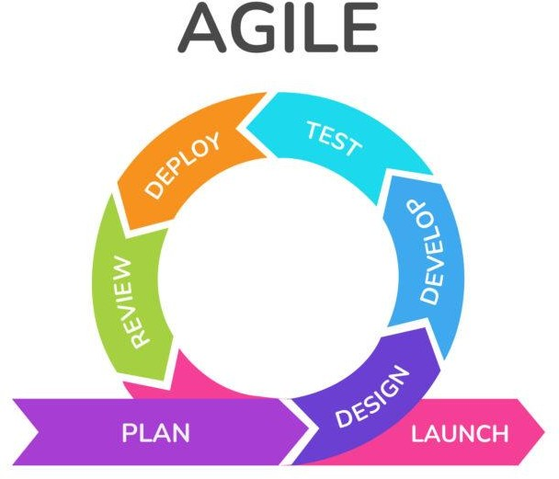

## Figure 3.6.1 Agile Model

The Agile thought process had started early in the software development and started becoming popular with time due to its flexibility and adaptability.

Following are the Agile Manifesto principles –

* + **Individuals and interactions** – In Agile development, self-organization and motivation are important, as are interactions like co-location and pair programming.
  + **Working software** – Demo working software is considered the best means of communication with the customers to understand their requirements, instead of just depending on documentation.
  + **Customer collaboration** – As the requirements cannot be gathered completely in the beginning of the project due to various factors, continuous customer interaction is very important to get proper product requirements
  + **Responding to change** – Agile Development is focused on quick responses to change and continuous development.

# CHAPTER 04 SYSTEM DESIGN

## SYSTEM ARCHITECTURE

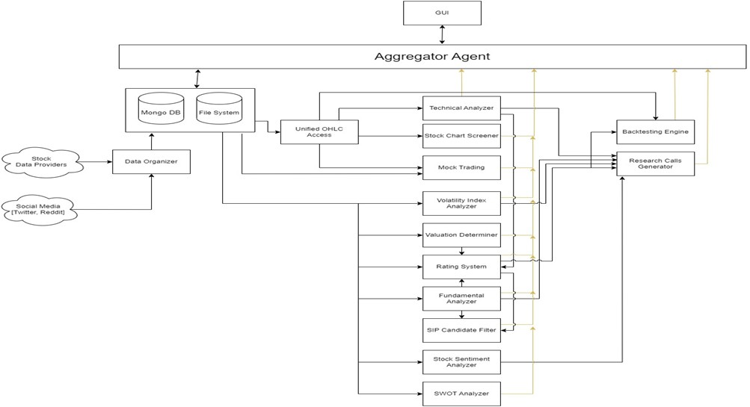

* 1. **System Architecture Diagram**

## SEQUENCE MODEL DIAGRAM

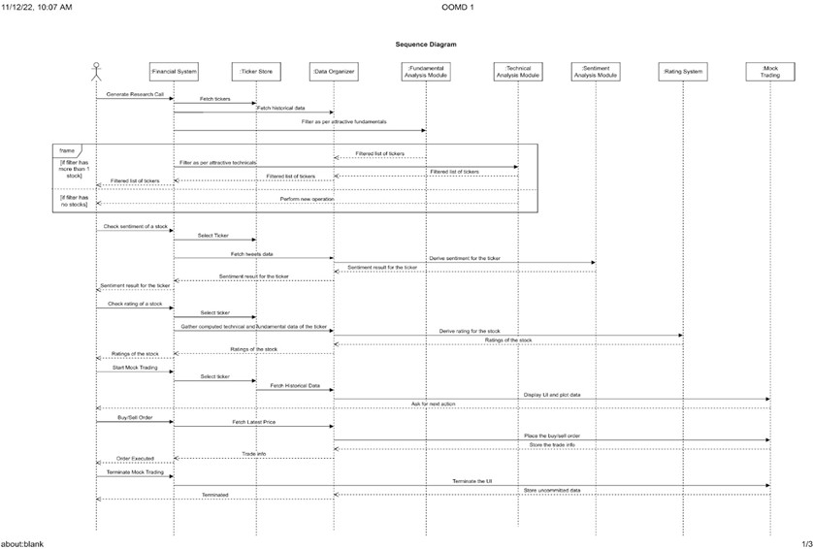

* 1. **Sequence Model Diagram**

## DATA FLOW DIAGRAMS

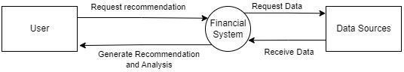

* 1. **Data Flow Diagram Diagram**

## UML DIAGRAMS

* + 1. **USE CASE DIAGRAM**

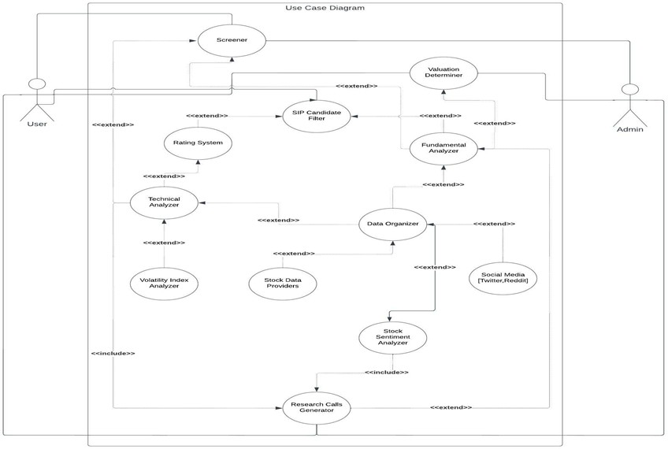

## Use Case Diagram

* + 1. **COMMUNICATION DIAGRAM**

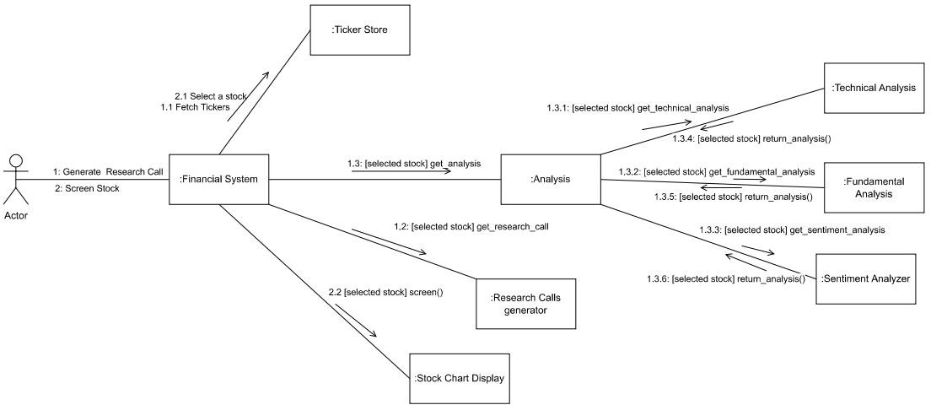

## Communication Diagram

* + 1. **ACTIVITY DIAGRAM**

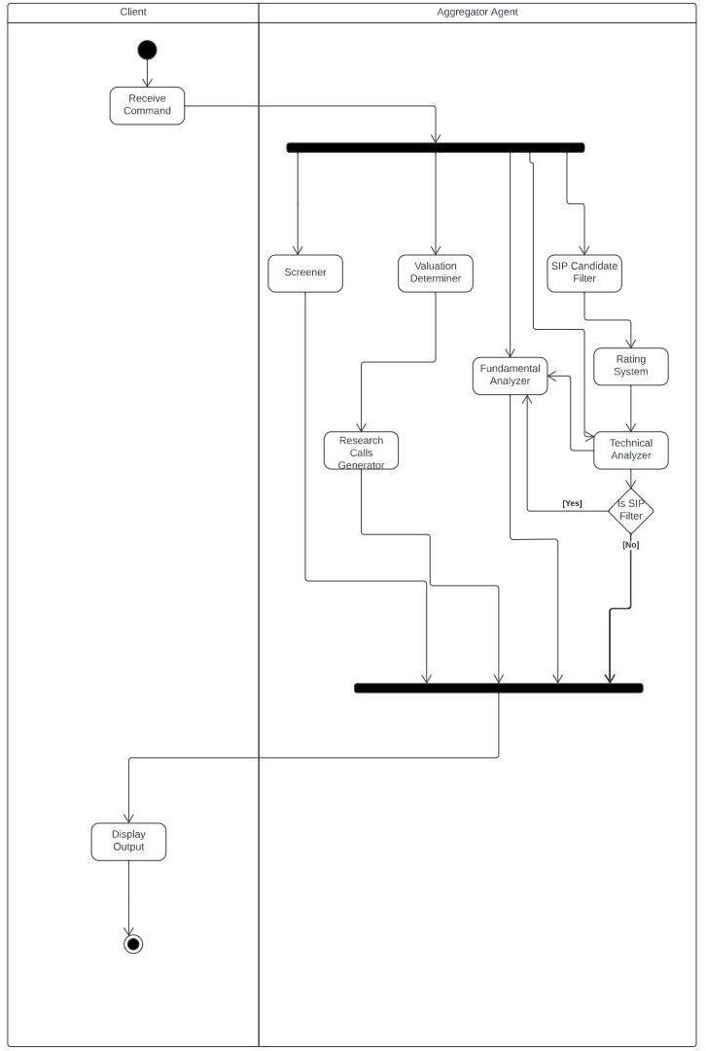

## Activity Diagram

* + 1. **COMPONENT DIAGRAM**

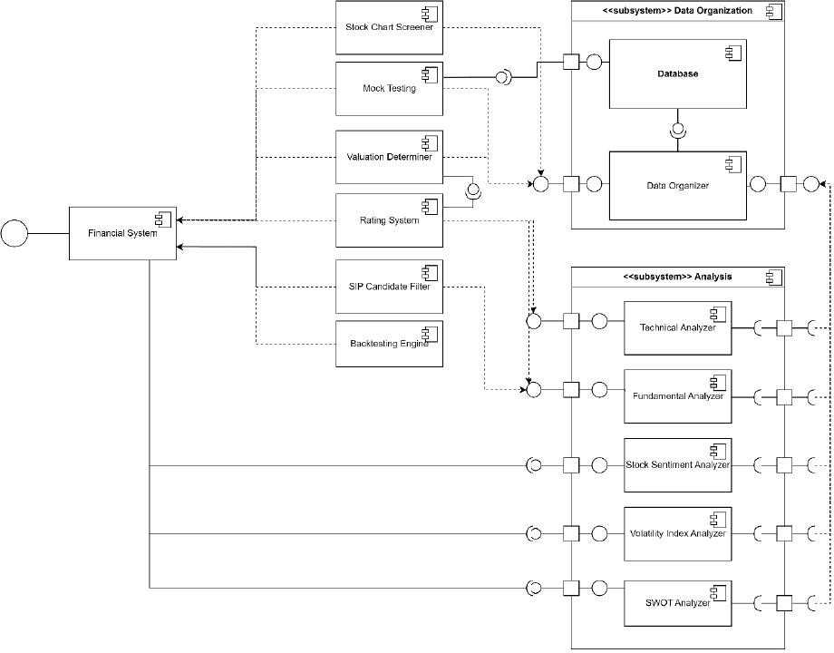

* + 1. **Component Diagram**

# CHAPTER 05 PROJECT PLAN

## PROJECT ESTIMATE

We have made a metric of some of the factors which will be directly involved in the project, called Project metric such as cost, time. Process metrics will be helpful to measure the quality of the product that is produced. These metrics can be analyzed to provide indicators for guide management and technical actions.

## Reconciled Estimates

* + - 1. **Time Estimates**

|  |  |
| --- | --- |
| **Month** | **Activity** |
| July 2022 | Requirement Gathering, Review of papers |
| August 2022 | Defining problem statement |
| September 2022 | Identifying scope and requirements of project |
| October 2022 | Functional requirement analysis |
| November 2022 | System design analysis |
| December 2022 | UML Diagrams |
| January 2023 | System Implementation |
| February 2023 | System Testing |
| March 2023 | Result Analysis |
| April 2023 | Documentation |

## 5.1.1.1 Time Estimatiion

* 1. **RISK MANAGEMENT**

## Risk Identification

Risk is an inevitable and inescapable component of the software development process. It continuously changes over the course of a project and can have an impact on the project, the product, or both. As a result, it becomes necessary to deal with and manage these risks in an effective and efficient way. As early as possible in the project, risks should be identified and dealt with. The project life cycle includes risk assessment, with a focus on significant milestones.

Identification of risks is one of the key topics covered during routine project status and reporting meetings. The project team will be able to predict some dangers right away, while others may require more diligence to find.

Some of the risks in this project are:

* + - 1. Dataset authentication: The data is collected from different open-source platforms. Hence, the validity and authenticity of the data needs to be monitored.
      2. Data Sources: Unreliable data source (in case the library is not maintained by the collaborators regularly) due to involvement of open source data gathering libraries. This may lead to inaccurate results.
      3. System Failure: The system may fail in any circumstances.

## Risk Analysis

* Risk analysis involves examining how project outcomes and objectives might change due to the impact of the risk event.
* Once the risks are identified, they are analyzed to identify the qualitative and quantitative impact of the risk on the project so that appropriate steps can be taken to mitigatethem.

## Overview of Risk Mitigation, Monitoring, Management

Risk mitigation is a technique for a data center to prepare for and mitigate the effects of risks. Risk mitigation, like risk reduction, aims to lessen the negative effects of risks anddisasters on business continuity. Cyber-attacks, weather occurrences, and other causes of physical or virtual harm to a data center are all potential threats to a corporation. Risks mustbe revisited at regular intervals for the team to re-evaluate each risk to see whether new conditions have changed its probability or impact. Individually owned and managed proactive measures are critical to successful risk management.

## PROJECT SCHEDULE

* + 1. **Project Task Set**

Task 1: Identifying Factors required narrowing down the steps in analysis process. Task 2: Identifying the data sources.

## Task Network

Individual tasks and subtasks have interdependencies based on their sequence. A task network is a graphic representation of the task flow for a project. Project tasks and their dependencies are noted

## Timeline Chart

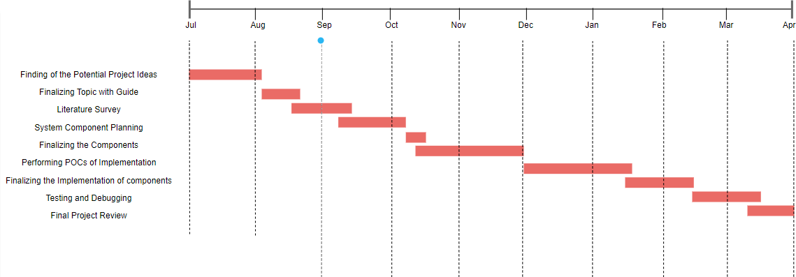

**5.3.3 Timline Diagram**

## TEAM ORGANISATION

* + 1. **Team Structure**

The project team is established. The team consists of four members, each with distinct responsibilities

1. Guide: Mr. Shailesh Galande
2. Team Members:
   1. Rahul Jadhav
   2. Dev Juneja
   3. Yash Khadse
   4. Jyoti Tapkir

## Management

|  |  |
| --- | --- |
| **Required Weeks** | **Work Completed** |
| 1st week -4th week | searching and selection of domain and project topics finalization |
| 6th week -11th week | literature survey and formation of problem definition |
| 12thweek -16th week | We were able to pinpoint the essence that  would be helpful for the project's launch and work well with emerging technology. |
| 17thweek -22nd week | Finalizing the modules needed in the project such as sentiment module, technical  module, SWOT module etc. |
| 22nd week – 25th week | Designing of various diagram such as  system architecture ,UML diagram’s etc. |
| 26th week- 29th week | Selection of proper algorithm which will give more accuracy and correct output |
| 30th week- 36th week | Implementation of backend for each  module simultaneously. |

|  |  |
| --- | --- |
| 37th week -39th week | Implementation of Front end part using Vue.js framework |
| 40th week | Integration of frontend and backend |
| 41st week- 43th week | Designing, implementing, and testing. And analyzing the system and designing test cases to uncover defects in the system |
| 44th week-45th week | Last two weeks were spent in the documentation. |

**5.4.2 Management Table**

# CHAPTER 06 PROJECT IMPLEMENTATION

## OVERVIEW OF PROJECT MODULES

* + 1. **VALUATION DETERMINER**

The Valuation Determiner considers a variety of the stock's financial factors before calculating its fair value using the book value, yearly sales, annual earnings, and Graham number. It determines if the stock is undervalued, reasonably valued, or overvalued after the computation is complete

Input:

* + - 1. Stock Name Output:

1. Valuation as per book value (VAP_BV)
2. Valuation as per annual sales (VAP_SALES)
3. Valuation as per earnings (VAP_EARNINGS)
4. Valuation as per Graham number (VAP_GRAHAM)
5. Status: Undervalued / Fairly Valued / Overvalued
   * 1. **MOCK TRADER**

Without using real money for trading, market participants can place simulated trades using Mock Trader. Participants in the market might use these trades to test a certain trading strategy or analysis

Input:

* + - 1. Stock Name
      2. Transaction type: Buy/Sell Output:

1. Trading position in the requested stock

* + 1. **SENTIMENT ANALYZER**

The Sentiment Analyzer module analyses option chain data for indices and securities to produce a sentiment that indicates whether the index or stock is oversold, slightly oversold, slightly overbought, or overbought

Input:

Output:

1. Stock Name

1. Sentiment for Nifty and Bank Nifty (needs no user input)
2. Sentiment for requested stock (oversold, slightly oversold, slightly

overbought, or overbought)

* + 1. **PATTERN ANALYZER**

Finding a certain technical chart pattern across all the stocks is done by the Pattern Analyzer module, which then outputs the stock name and a chart showing the pattern's position with a yellow pointer just above it. Also, it can exclude equities whose technical charts show a breakdown, breakout, or consolidation

Input:

* + - 1. Technical pattern name Output:

1. Candlestick chart of stocks where the pattern is located indicating the target pattern's position with yellow pointer.
2. List of stocks that witnessing consolidation, breakout or breakdown.
   * 1. **INDICES HEALTH**

This module employs a color-coded system to show the overall valuation status of all NSE indices. It makes use of the hues red, orange, and green. Green means that the valuations are good enough to begin SIPs, while orange and red indicate that the valuations are neutral and expensive respectively.

Output:

* + - 1. List of indices that are colored-wrapped
    1. **SWOT ANALYZER**

This module examines a stock's technical parameters and fundamentals before generating a SWOT that lists the stock's strengths, weaknesses, opportunities, and threats.

Inputs:

Output:

1. Stock name
   1. SWOT for the requested stock
      1. **FUNDAMENTAL SCANS**

This module examines the financial data of the stocks and sorts stocks that are attractive according to their Graham number, book value, annual sales, and earnings Output:

* + - 1. List of stocks attractive as per its book value.
      2. List of stocks attractive as per its sales.
      3. List of stocks attractive as per its earnings.
      4. List of stocks trading below Graham Number
    1. **CRYPTO TECHNICAL SCANS**

For traders' convenience, this module analyses the technical charts of the specified cryptocurrency and then generates a plot showing the automatically generated support and resistance levels for that cryptocurrency.

Inputs:

* + - 1. Cryptocurrency name

Output:

1. List of stocks attractive as per its book value.
2. List of stocks attractive as per its sales.
3. List of stocks attractive as per its earnings.
4. List of stocks trading below Graham Number
   * 1. **STRATEGY BACKTESTER**

For any requested stock, this module now backtests a hardcoded trading strategy and generates a visually appealing report with information on the number of trades, total returns, maximum drawdown, and average return.

Inputs: Output:

1. Stock name
   1. A plot indicating the backtest results for the requested stock

## BUY/SELL SIGNALS GENERATOR

For any requested stock, this module produces a visually appealing plot with long/short green and red colored markers respectively as signals. These signals can be used to interpet the further direction of the stock.

Inputs:

* + - 1. Stock name
      2. Number of signals (total number of buy or sell signals that must be plotted) Output:

1. A visually appealing plot indicating buy and sell signals for the requested stock.

## TOOLS AND TECHNOLOGIES USED

* + 1. **Python :**

Python Programming Language was used to implement the backend and many

scripts involved in the web Application**.**

## Vue.js

The front end was built using Vue.js framework of JavaScript**.**

## Visual Studio

VScode or Visual Studio was a platform for writing codes**.**

## GitHub

It's used for storing, tracking, and collaborating on software projects. It makes it

easy for us to share code files and collaborate with fellow developers on open-source projects**.**

# CHAPTER 07 SOFTWARE TESTING

## TYPE OF TESTING

The purpose of testing is to identify flaws. Testing is the process of looking for defects or vulnerabilities in a work product. Individual components, subassemblies, assemblies and/or a completed product can be tested. It is the process of verifying that software fulfils specifications, meets user expectations, and does not fail in an unacceptable manner. There areseveral tests to choose from. The following is a list of them.

## BLACK BOX TESTING

Black Box Testing, also known as Behavioral Testing, is a [software testing method](http://softwaretestingfundamentals.com/software-testing-methods/) in which the internal structure/design/implementation of the item being tested is not known to the tester. These tests can be functional or non-functional, though usually functional.

Black*-*box testing is a method of software testing that examines the functionality of an application without peering into its internal structures or workings. Black-box testing is a method of software testing that examines the functionality of an application based on the specifications. It is also known as Specifications based testing. Independent Testing Team usually performs this type of testing during the software testing life cycle.

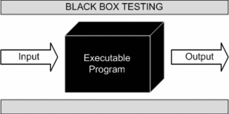

7.1.1Black Box Testing

Black box testing method is applicable to the following levels of software testing

* Integration Testing
* System Testing
* Acceptance Testing

The higher the level and hence the bigger and the complex the box, the balck box testing method comes into use.

## WHITE BOX TESTING

White-box testing is a method of software testing that tests internal structures or workings of an application, as opposed to its functionality. In white-box testing an internal perspective of the system, as well as programming skills, are used to design test cases.

White box testing is testing of a software solution's internal structure, design, and coding. In this type of testing, the code is visible to the tester. It focuses primarily on verifying the flow of inputs and outputs through the application, improving design and usability, strengthening security. White box testing is also known as Clear Box testing, Open Box testing, Structural testing, Transparent Box testing, Code-Based testing, and Glass Box testing. It is usually performed by developers.

## OTHER TESTING TYPES 7.1.3.1.UNIT TESTING

Unit testing is a level of software testing where individual units/ components of a software are tested. The purpose is to validate that each unit of the software performs as designed. A unit is the smallest testable part of any software. It usually has one or a few inputs and usually a single output.

Unit testing, a testing technique using which individual modules are tested to determine if there are any issues by the developer himself. A unit test is a way of testing a unit - the smallest piece of code that can be logically isolated in a system**.**

## INTEGRATION TESTING

Integration testing is the phase in software testing in which individual software modules are combined and tested as a group. Integration testing is conducted to evaluate the compliance of a system or component with specified functional requirements. It occurs after unit testing and before validation testing.

## SYSTEM TESTING

System testing is testing conducted on a complete integrated system to evaluate the system's compliance with its specified requirements. System testing takes, as its input, all of the integrated components that have passed integration testing.

System testing is a level of testing that validates the complete and fully integrated software product. The purpose of a system test is to evaluate the end-to-end system specifications. Usually, the software is only one element of a larger computer-based system**.**

## PERFORMANCE TESTING

Performance testing is the process of determining the speed, responsiveness and stability of a computer, network, software program or device under a workload. Performance testing can involve quantitative tests done in a lab, or occur in the production environment in limited scenarios. In software quality assurance, performance testing is in general a testing practice performed to determine how a system performs in terms of responsiveness and stability under a particular workload**.**

# CHAPTER 08 RESULTS

## OUTCOMES

Fin-Maestro has been tested extensively to ensure the accuracy and reliability of the financial data provided to users. The modules have been tested individually and in combination to ensure seamless integration and user experience. The application has received positive feedback from users, who have praised the application's ease of use and accuracy

## SCREENSHOTS

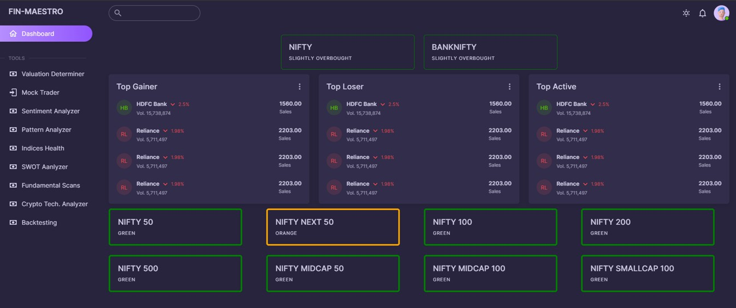

**Figure 8.2.1 Fin- Maestro Dashboard**

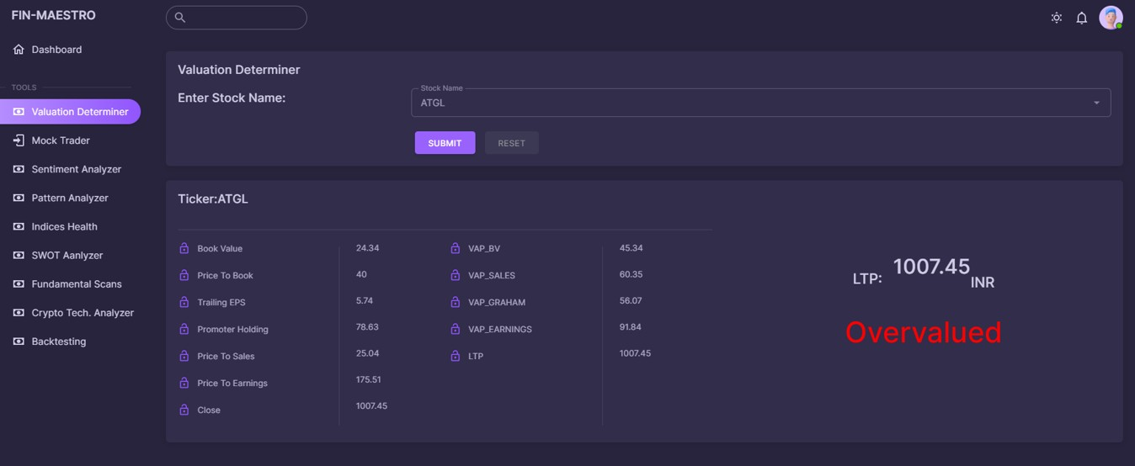

## Figure 8.2.2 Valuation Determiner

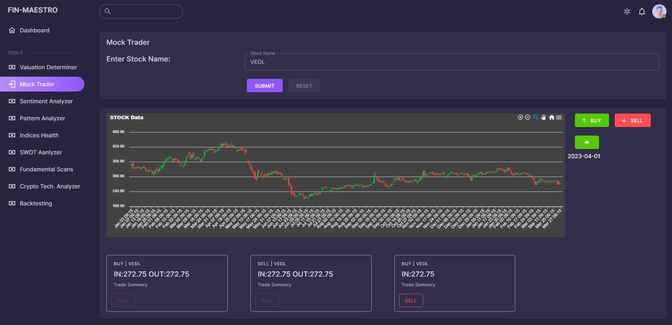

**Figure 8.2.3 Mock Trader**

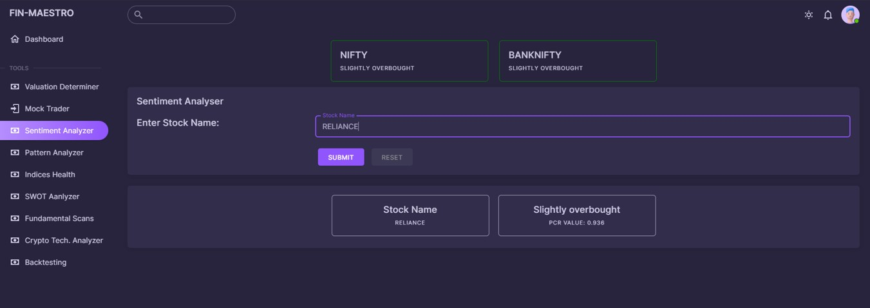

## Figure 8.2.4 Sentiment Analyzer

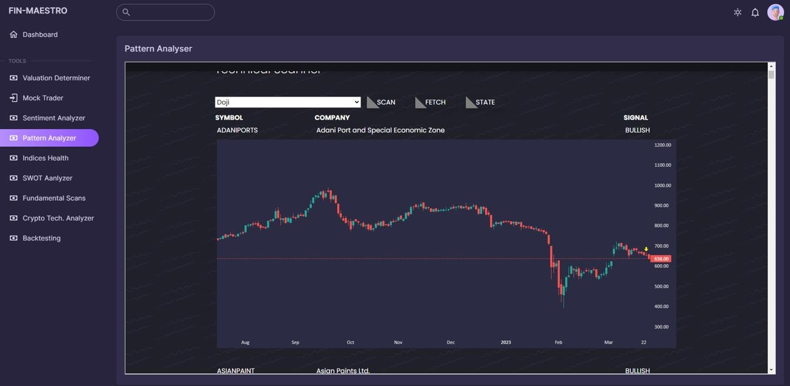

**Figure 8.2.5 Pattern Analyzer**

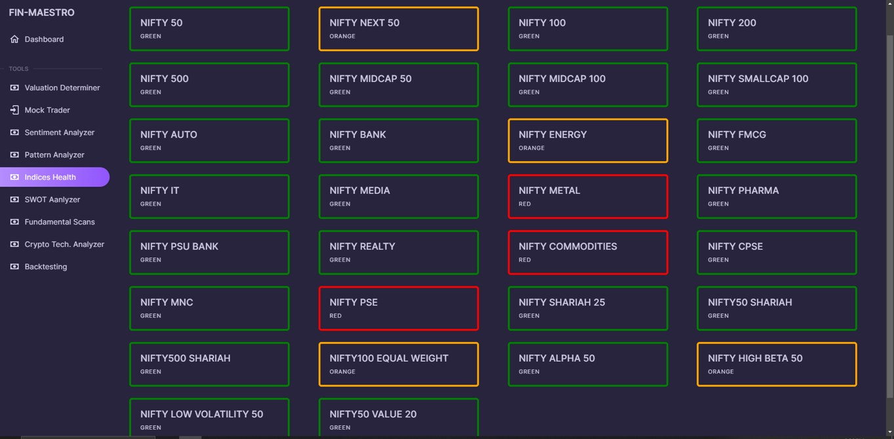

## Figure 8.2.6 Indices Health

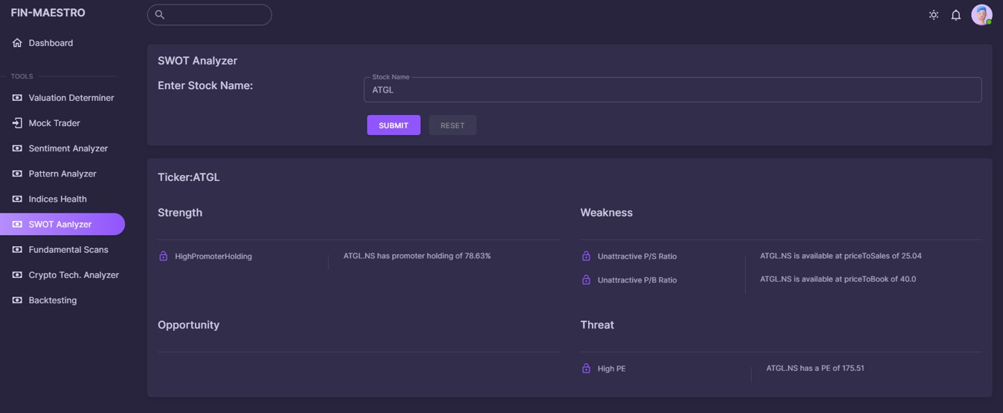

**Figure 8.2.7 SWOT Analyzer**

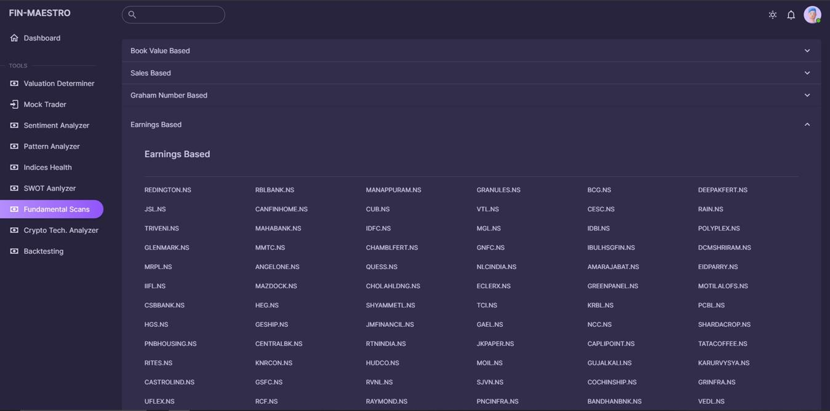

## Figure 8.2.8 Fundamental Scans

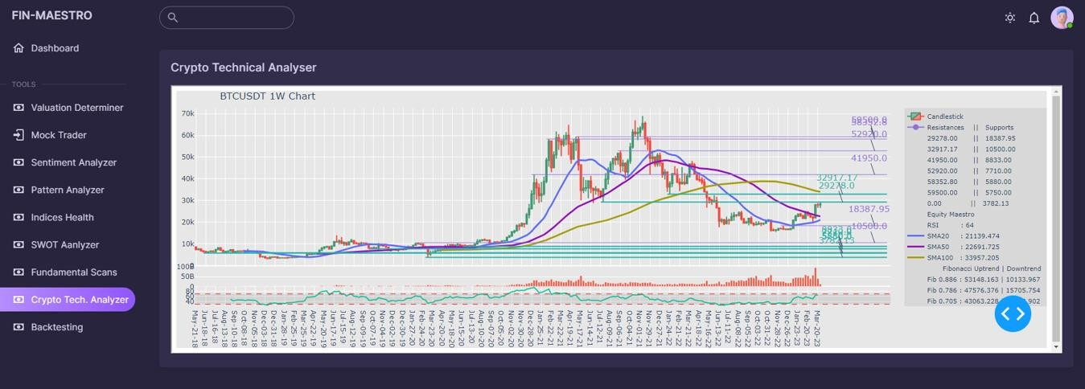

**Figure 8.2.9 Crypto Technical Scans**

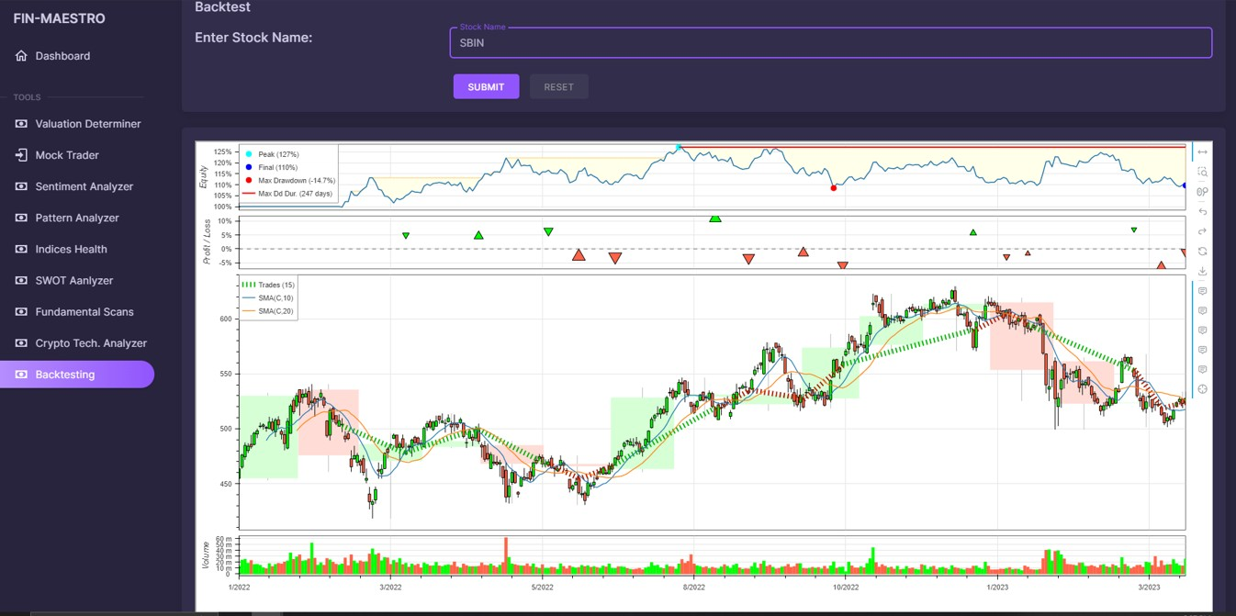

## Figure 8.2.10 Strategy Backtester

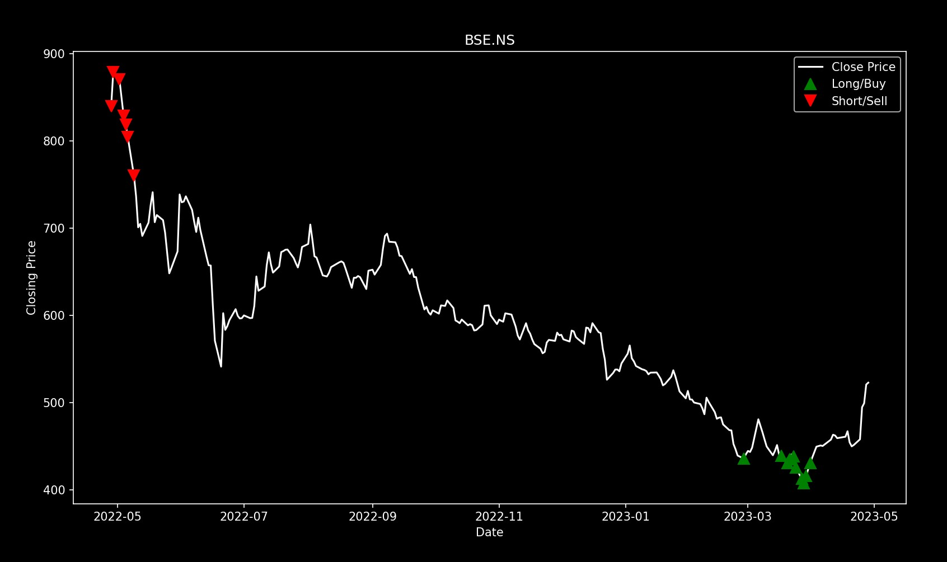

**Figure 8.2.11 Buy/Sell Signals Generator**

.

# CHAPTER 09 CONCLUSION

## CONCLUSION

A full-fledged platform is developed which will aid the retail trader, investor to gain insights for both long term, short term time frame. Fin-Maestro, a web application that aims to provide an efficient and intelligent way for market participants to analyze various parameters of financial instruments. The nine main techniques included in the application have demonstrated improved accuracy in predicting financial outcomes, indicating that it is indeed possible to achieve greater accuracy and efficiency in predicting the stock market using these techniques. In a nutshell, this platform will help retail investors, traders to spot decent opportunities in the markets more quickly and efficiently to make profitable trades.

## FUTURE WORK

The financial sector is constantly evolving, and there are several factors and parameters that play a crucial role in its growth and development. The future of the financial sector is likely to be shaped by various trends and technologies, including:

* + - Artificial Intelligence (AI): AI has already started to transform the financial sector by automating processes, reducing costs, and improving efficiency. In the future, AI is likely to play an even more significant role in areas such as fraud detection, risk management, and customer service.
    - Blockchain Technology: Blockchain technology has the potential to revolutionize the financial sector by making transactions faster, cheaper, and more secure. It could also reduce the need for intermediaries such as banks and clearinghouses..
    - Data Analytics: The financial sector generates vast amounts of data, and data analytics is becoming increasingly important in making sense of this data. In the future, data analytics is likely to play an even more critical role in areas such as risk management, customer segmentation, and product development.
    - Cyber security: With the increasing use of technology in the financial sector, cyber security is becoming even more critical. In the future, cyber security will continue to be a top priority for financial institutions to protect against data breaches and cyber attacks.

.

The other factor is the crypto currencies. The future of crypto currencies is a topic of much discussion and debate. While crypto currencies have faced several challenges in their early years, they have gained significant popularity and acceptance in recent times. As we have developed the web application which can also be then implemented as mobile application. Mobile applications offer several advantages over mobile websites, including convenience, personalization, speed, accessibility, offline access, integration with device features, and security.

Integration of existing modules with a Telegram Bot named Fin-Maestro.

* + - Description: This integration will ensure that the modules of Fin-Maestro can be accessed more easily and conveniently by it's users with single line commands via Telegram. For example: To fetch the valuation of a specific stock, the following command can be used: /valuation ticker-name.

## APPLICATIONS

* + - Determine the fair value of a stock based on several financial parameters.
    - Allow users to place mock trades for the purpose of testing the web app.
    - Supports backtesting of technical strategies.
    - Produces buy/sell signals for a stock in the form of plot based on technical parameters.
    - Enables users to detect technical chart patterns**.**

# APPENDIX A

This problem can be classified as an NP-Complete problem as all the algorithm exists in polynomial time, all problems in NP would be polynomial time solvable. It satisfies both an NP and NP-hard. With the exception of the sentiment, algorithms that fall under the category of NP- hard problems can be solved in polynomial time. And where we are unable to receive definitive answers

# APPENDIX B

* + 1. **Title of Paper**: A Review on Usage of Machine Learning in Technical and Fundamental Analysis

**Publisher**: IRJET

**Name of Author:** Jyoti Tapkir, Dev Juneja, Yash Khadse, Rahul Jadhav

**Status:** Published



# APPENDIX C

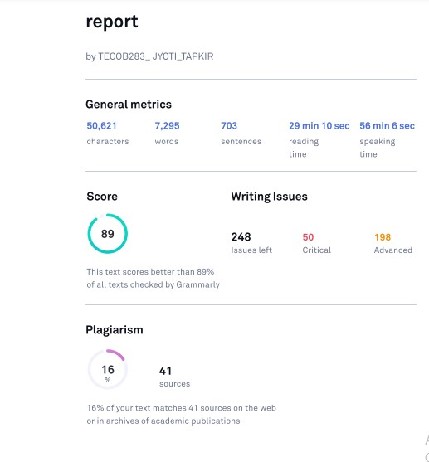

**REFERENCES**

1. (Yash, Atharva, Radha, 2021). Stock Price Prediction using Machine Learning and Sentiment Analysis, 2021 2nd International Conference for Emerging Technology (INCET) Belgaum, India.

May 21-23, 2021

1. Predicting Stock Closing Price After COVID-19 Based on Sentiment Analysis and LSTM: (Christopher Chou1, Junho Park2, Eric Chou3) IAEAC 2021(ISSN 2689-6621)
2. Sentiment Stock Based Prediction (B. L. Pooja, SuvarnaKanakaraddi, Meenaxi .M. Raikar) 2018 International Conference on Computational Techniques, Electronics and Mechanical Systems (CTEMS)
3. A Novel Twitter Sentiment Analysis Model with Baseline Correlation for Financial Market Prediction with Improved Efficiency (XinyiGuo†, Jinfeng Li*) 2019 Sixth International Conference on Social Networks Analysis, Management and Security (SNAMS)
4. Stock Price Prediction Using News Sentiment Analysis (Saloni Mohan1, Sahitya Mullapudi1, Sudheer Sammeta1) 2019 IEEE Fifth International Conference on Big Data Computing Service and Applications (BigDataService).
5. An Entropy-based Evaluation for Sentiment Analysis of Stock Market Prices using Twitter Data (Andreas Kanavos∗, GerasimosVonitsanos∗)_ 2020 IEEE
6. Machine Learning for Stock Prediction Based on Fundamental Analysis (Yuxuan Huang; Luiz Fernando Capretz; Danny Ho) 2021 IEEE Symposium Series on Computational Intelligence (SSCI)
7. Stock price prediction using MLR on Sentiments and Fundamental Profile (AkshatGoe) 2021 12th International Conference on Computing Communication and Networking Technologies (ICCCNT)
8. Stock market analysis using candlestick regression and market trend prediction (CKRM) M. Ananthi1 · K. Vijayakumar2 : Received: 12 October 2019 / Accepted: 13 March 2020 © Springer-

Verlag GmbH Germany, part of Springer Nature 2020

1. Efficient predictability of stock return volatility: The role of stock market implied volatility ZhifengDaia, HuitingZhoua, FenghuaWenb,c,⁎ , ShaoyiHed
2. Neural networks and arbitrage in the VIX A deep learning approach for the VIX Joerg Osterrieder1 · Daniel Kucharczyk2 · Silas Rudolf3 · Daniel Wittwer4
3. Ticknor, J. L.(2013). A Bayesian regularized artificial neural network for stock market forecasting. Expert Systems with Applications, 40(October (14)), 5501–5506.
4. Lo, A. W., Mamaysky, H., & Wang, J. (2000). Foundations of technical analysis: Computational algorithms, statistical inference, and empirical implementation. The Journal of Finance, 55(August (4)), 1705–1770
5. Oppenheimer, H. R., & Schlarbaum, G. G. (1981). Investing with Ben Graham: An Ex Ante test ofthe efficient markets hypothesis. Journal of Financial and Quantitative Analysis, 16(September (3)), 341–360
6. Metghalchi, M., Chang, Y.-H., & Marcucci, J. (2008). Is the Swedish stock market efficient? Evidence from some simple trading rules. International Review of Financial Analysis, 17(June (3)), 475–490.
7. Bahtiar J. Z. , Rosnalini M, Norhayati Y, Beh Hui Sang. (2019) Classify Stock Market Movement Based on Technical Analysis Indicators Using Logistic Regression, Journal of Advanced Research in Business and Management Studies 14, Issue 1 (2019) 35-41
8. Rohit C., Kumkum G. (2008) A Hybrid Machine Learning System for Stock Market Forecasting, World Academy of Science, Engineering and Technology 15 2008
9. Teaba W. A. K., Rana M., Wasim A. (2019) Stock Price Prediction using Technical, Fundamental and News based Approach, 2019 2nd Scientific Conference of Computer Sciences (SCCS)
10. Yuxuan H., Luiz F. C., Danny H., (2019) Neural Network Models for Stock Selection Based on Fundamental Analysis, 32nd Canadian Conference on Electrical & Computer Engineering, Edmonton, Canada, 2019
11. Andrea P. R., Simone M., Luca O., Yukun M., Lorenzo M., Erik C., (2018) 18-21 Nov 2018 IEEE Symposium Series on Computational Intelligence (SSCI)
12. Isaac K. N., Adebayo F. A., Benjamin A. W., (2019) A systematic review of fundamental and technical analysis of stock market predictions, April 2020 Artificial Intelligence Review 53(7)